Negative production externality is negative effects suffered by a third party whose interests are not considered when a good or service is produced, so the third party is therefore not compensated. Indirect taxes are taxes on expenditures to buy goods and services. On 2012.7.1, the Australian Federal government introduced a carbon price of AUD $23 per ton of emitted CO2 on fossil fuels.

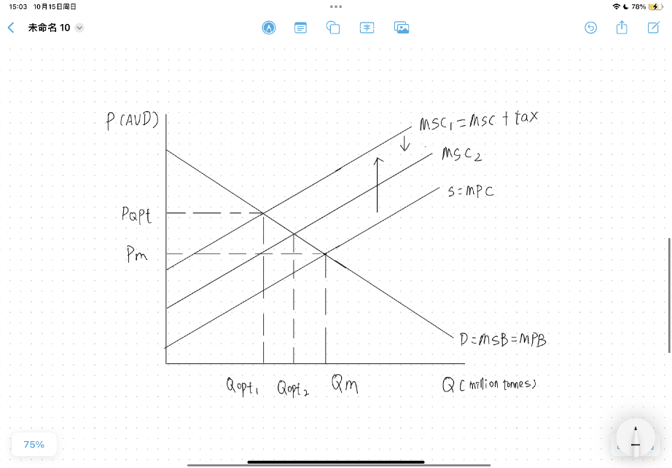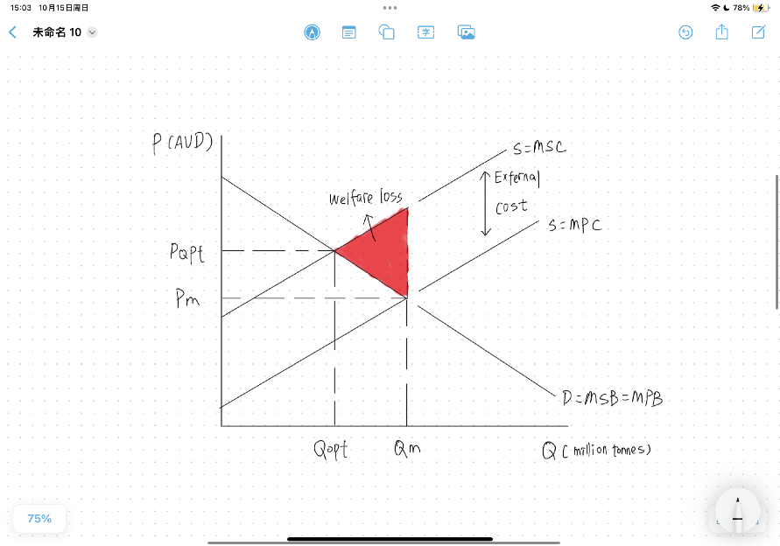

From Figure 1, when MPB=MPC, the market equilibrium Qm and market equilibrium price Pm is determined. Demand equals MPB and MSB. Supply equals MPC, which reflects the firm's private cost of production. However, the action of suppliers results in external cost to society, such as emitting wasted gas into atmosphere, so the MPC is not equal to MSC anymore. When MSB equals MSC, the socially optimum output and the socially optimum price is determined. The market equilibrium output is 17.27 million tones, and the market socially optimum output is 16.97 million tones. For each level of output, the social costs of producing the product given by MSC are greater than the firm's private costs. The vertical difference between MSC and MPC represents the external costs. The free market overallocates resources to the production of the good and too much is produced relative to the social optimum. Also, there will be welfare loss, and consumer surplus and producer surplus will decrease. The carbon tax is a tax per unit of carbon emissions of fossil fuels. From Figure 2, the government imposes carbon tax which is 23 AUD per tones of emitted CO2 on fossil fuels to the market, so there is a higher cost of production, which will result in an upward shift in S=MPC toward MSC because firms must pay the higher price to buy the fossil fuels. If the firm switches to alternative or less polluting resources or does not emit carbon dioxide, the external costs of producing the output will be smaller, so MCS1 will shift downwards toward MSC2, and the social output will increase from Q1 to Q2. The carbon tax reduces the size of the negative externality production and increases the socially optimum quantity of output. It also partially corrects the overallocation of resources to the good, reducing the quantity of output produced.

**Advantages:** Government tax revenue increased after the carbon taxes were imposed. The scheme aimed to prevent 160 million tons of carbon dioxide from entering the atmosphere by 2020, as well as generating $24 billion over three years. As a result, Australia's gross domestic product successfully grew at a rate of 2.5% per year. The government tax revenue received can be used to provide support and fund green technologies. With a five-year fall in greenhouse emissions, the government granted an increase in wind generation supported by the Renewable Energy Subsidies. The carbon tax provides incentives for producers to reduce the pollution and to be more efficient, it leads to lower pollution levels at a lower overall cost to society by doing technological development or renewable resources. On July 17, 2014, a report by the Australian National University estimated that the Australian scheme had cut carbon emissions by as much as 17 million tons. Carbon emissions in 2011 were 17.27 metric tons. By 2012, carbon emissions were 16.97 metric tons. Also, because of the imposition of the carbon tax, some producers prefer to exit the market. Meanwhile, there is a burst in residential solar PV generation, more electricity producer tends to use renewable energy to reduce their cost. The imposition of carbon taxes helps to internalize the externality: the costs that were previously external are made internal, and they are now paid by producers and consumers. In May 2012, the Australian Competition & Consumer Commission (ACCC) reported that it was investigating about 100 cases of complaints for the excessing pricing claimed to be due to the carbon tax as a result of the indirect flowing of the carbon tax through to consumers. Farmers and grazers would have been encouraged to plant trees to earn carbon credits, which could have been on-sold to companies liable to pay a carbon price.

**Disadvantages:** One disadvantage for carbon tax is that companies may reduce new investment in the industry with a high carbon tax because they can receive less profit. This may force them to shift production to new developing countries with lower carbon taxes to increase profit, which decreases the government revenue in the original country, cutting employment and can therefore cause problem as unemployment. In Australia’s carbon pricing, the Sydney Morning reported that Clean Energy Future carbon price scheme had deterred new investment significantly in the coal industry In February 2012, as spending on production had increased by 62% in 2010–2011, more than any other mineral commodity. The monitoring cost of the carbon tax is intensive, since the government have to make sure companies do not violate the laws secretly. Without supervision, this policy can be meaningless. Statistics shows that this tax cost twice as much as non-tax environmental policies, as carbon tax requires far more monitoring cost. It is also difficult to design effective carbon taxes in terms of determining which pollutants is harmful and how much we should tax. The carbon tax in Australia primarily focuses on the coal industry, while neglecting other potential carbon pollutants. Therefore, other pollutants which is more harmful than CO2 in the coal industry may be directly discharged into the air, making this policy less effective in regulating harmful pollutants. To impose this tax is politically difficult. In Australia, huge international companies as Qantas and Virgin are opposing this tax because the increased price of aircraft fuel due to this tax has reduce the profit of this airline company. To counteract this tax, they must raise the flight ticket by 1.5%, which further increase the cost of flying for people in the Covid era. Since demand for flights is inelastic, the increased price would be a burden for the low income, as the ticket account for a larger proportionate of income for them.